Spring Season

SPRING

When is the Spring season?
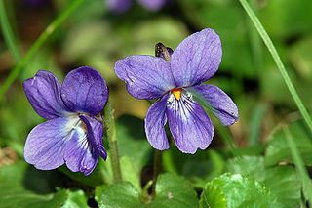
Spring is the season succeeding Winter and preceding Summer. Spring refers to the season as well as to ideas of rebirth, rejuvenation, renewal, resurrection, and regrowth. During Spring an important celebration takes place: Easter Day. It varies between March 22 and April 25 in Western tradition, and between April 4 and May 8 in Eastern Christianity.

What happens in spring?
Spring is a time when flowers bloom and trees begin to grow and reproduce. The days grow longer and the temperature in most areas become more temperate. You can also contemplate the melting of ice and thawing of the ground. The weather during this period becomes much sunnier while hibernating animals begin to come out of hibernation.

What to do during the Spring Season?
There are so many things to do to enjoy Spring:
- Plan a holiday and make a trip. Vacations aren't just for summer anymore!
- Take a walk in a field of flowers.
- Meditate: Contemplate and reflect on the beauty of nature. Forget the worries of evreyday life and empty the mind. Concentrate on the sounds and the scent of nature.
- Spot the things you want to change in your life. Spring is a time for rebirth.

