Mark 10:13-16 The Little Children and Jesus 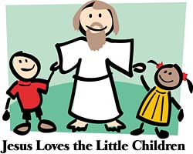
¹³ People were bringing little children to Jesus for him to place his hands on them, but the disciples rebuked them. ¹⁴ When Jesus saw this, he was indignant. He said to them, “Let the little children come to me, and do not hinder them, for the kingdom of God belongs to such as these. ¹⁵ Truly I tell you, anyone who will not receive the kingdom of God like a little child will never enter it.” ¹⁶ And he took the children in his arms, placed his hands on them and blessed them.

-------------- --------------------- ------------------

Do you remember your childhood?

- What did you look like?
Were you tall? thin? pretty? handsome? cute?
Did you have curly hair? strait hair? long hair?
Did you have dimples? freckles?

- Did you have many friends
What did you do with your friends?
What games did you play?

- Did you like school?
Who was your favorite teacher? Why?
What was your favorite subject? Why?

- Who was your favorite hero/celebrity?

- How old were you when you went on your first date?

