John 19:25-27
New International Version (NIV)
²⁵ Near the cross of Jesus stood his mother, his mother’s sister, Mary the wife of
Clopas, and Mary Magdalene. ²⁶ When Jesus saw his mother there, and the
disciple whom he loved standing nearby, he said to her, “Woman,^{[a]} here is your
son,” ²⁷ and to the disciple, “Here is your mother.” From that time on, this
disciple took her into his home.

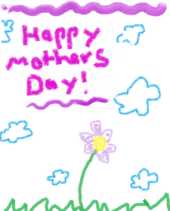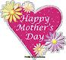

- What images spring to your mind when you hear the word ‘mother’?

- Can you describe you r mother in one word? Why that word?

- What’s the best piece of advice that your mother has given you?

